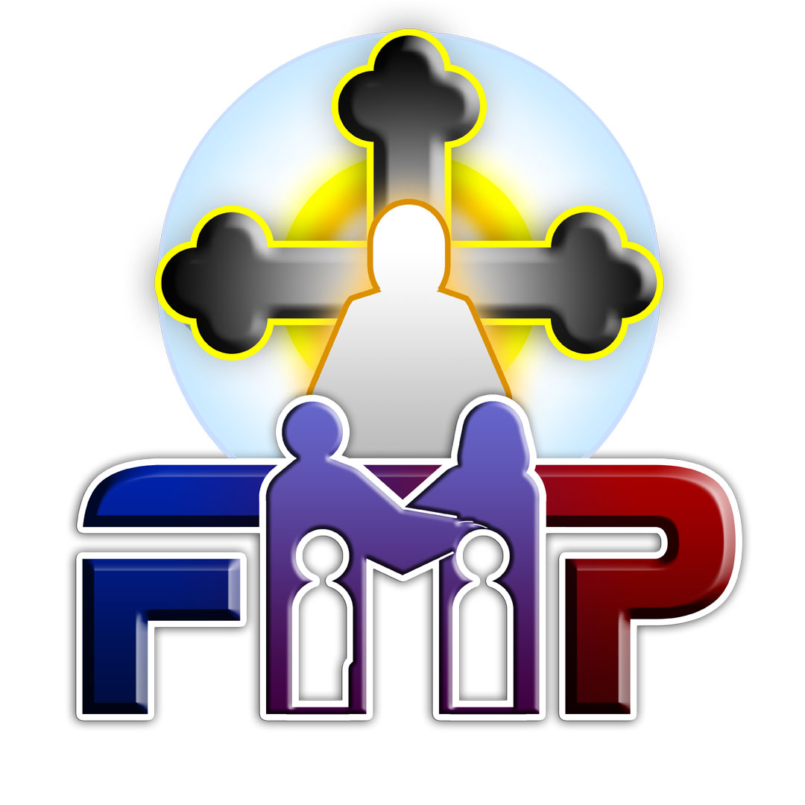
Family Ministry Program
A Program of the Coptic Orthodox Diocese of the Southern US

Fall Daily Schedule
August 30th – September 1st, 2024

Times are in EST Semester ends on 11/29/24
Thursday Night: Arrival and Registration
Friday
7:30 | – | 8:00 | AM |  | Morning Agpeya Prayer
8:00 | – | 9:00 | AM |  | Breakfast
9:00 | – | 10:30 | AM |  | Domestic Violence #1
10:30 | – | 11:00 | AM |  | Break
11:00 | – | 12:30 | PM |  | Ethics + Practicum I #1
12:30 | – | 1:30 | PM |  | Lunch
1:30 | – | 3:00 | PM |  | Ethics + Practicum I #2
3:00 | – | 3:30 | PM |  | Break
3:30 | – | 5:00 | PM |  | Domestic Violence #2
5:00 | – | 5:30 | PM |  | Agpeya Prayer
5:30 | – | 7:00 | PM |  | Ethics + Practicum I #3
7:00 | – | 8:00 | PM |  | Dinner
8:00 | – | 9:30 | PM |  | Domestic Violence #3
9:30 | – | 10:00 | PM |  | Admin Meeting- Students
Saturday
7:30 | – | 8:00 | AM |  | Morning Agpeya Prayer
8:00 | – | 9:00 | AM |  | Breakfast
9:00 | – | 10:30 | AM |  | Domestic Violence #4
10:30 | – | 11:00 | AM |  | Break
11:00 | – | 12:30 | PM |  | Ethics + Practicum I #4
12:30 | – | 1:30 | PM |  | Lunch
1:30 | – | 3:00 | PM |  | Challenges Facing Christian Marriage #1
3:00 | – | 3:30 | PM |  | Break
3:30 | – | 5:00 | PM |  | Challenges Facing Christian Marriage #2
5:00 | – | 6:00 | PM |  | Vespers Prayer
6:00 | – | 7:30 | PM |  | Human Sexuality #1
7:30 | – | 8:30 | PM |  | Dinner
8:30 | – | 10:00 | PM |  | Challenges Facing Christian Marriage #3
Sunday
7:30 | – | 8:00 | AM |  | Morning Incense
8:00 | – | 10:00 | AM |  | Divine Liturgy
10:00 | – | 11:00 | AM |  | Breakfast
11:00 | – | 12:30 | PM |  | Challenges Facing Christian Marriage #4
12:30 | – | 1:00 | PM |  | Break
1:00 | – | 2:30 | PM |  | Free Time
2:30 | – | 3:30 | PM |  | Lunch
3:30 | – | 5:00 | PM |  | Human Sexuality #2
5:00 | – | 5:30 | PM |  | Agpeya Prayer
5:30 | – | 7:00 | PM |  | Human Sexuality #3
7:00 | – | 8:00 | PM |  | Dinner
8:00 | – | 9:30 | PM |  | Human Sexuality #4

Courses | Instructors
Domestic Violence | Irene Salidis, MA
Ethics | Karen Naguib, MSED
Practicum I | Mary Michail, MA
Challenges Facing Christian Marriage | Naglaa Moussa, MA
Human Sexuality | Margo Rizk, MA

