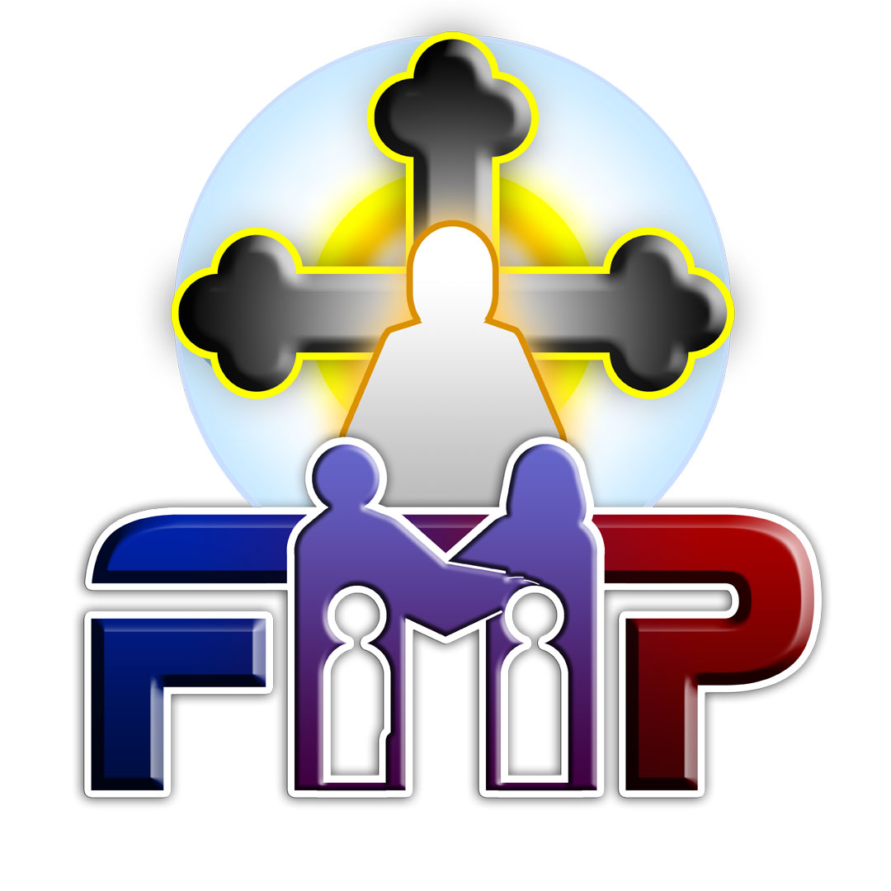
Family Ministry Program
A Program of the Coptic Orthodox Diocese of the Southern US

Fall Daily Schedule
August 29th–31st, 2025

Times are in EST Semester ends on11/28/2025
Thursday Night: Arrival and Registration
Friday
7:30 | – | 8:00 | AM |  | Morning Agpeya Prayer
8:00 | – | 8:40 | AM |  | Breakfast
8:40 | – | 9:00 | AM |  | Admin Meeting
9:00 | – | 10:30 | AM |  | Family Systems #1
10:30 | – | 11:00 | AM |  | Break
11:00 | – | 12:30 | PM |  | Ethics + Practicum I #1
12:30 | – | 1:30 | PM |  | Lunch
1:30 | – | 3:00 | PM |  | Family Systems #2
3:00 | – | 3:30 | PM |  | Break
3:30 | – | 5:00 | PM |  | Ethics + Practicum I #2
5:00 | – | 5:30 | PM |  | Agpeya Prayer
5:30 | – | 7:00 | PM |  | Family Systems #3
7:00 | – | 8:00 | PM |  | Dinner
8:00 | – | 9:30 | PM |  | Family Systems #4
 |  |  |  |  |  |  |  |  |  | Ethics + Practicum I #2
Saturday |  |  |  |  |  |  |  |  |  | Morning Agpeya Prayer
7:30 | – | 8:00 | AM |  | Breakfast
8:00 | – | 9:00 | AM |  | Ethics + Practicum I #3
9:00 | – | 10:30 | AM |  | Break
10:30 | – | 11:00 | AM |  | Ethics + Practicum I #4
11:00 | – | 12:30 | PM |  | Lunch
12:30 | – | 1:30 | PM |  | The Spirituality of the Helper #1
1:30 | – | 3:00 | PM |  | Break
3:00 | – | 3:30 | PM |  | The Spirituality of the Helper #2
3:30 | – | 5:00 | PM |  | Vespers Prayer
5:00 | – | 6:00 | PM |  | The Spirituality of the Helper #3
6:00 | – | 7:30 | PM |  | Dinner
7:30 | – | 8:30 | PM |  | The Spirituality of the Helper #4
Sunday |  |  |  |  |  |  |  |  |  | Morning Incense
7:30 | – | 8:00 | AM |  | Morning Incense
8:00 | – | 10:00 | AM |  | Divine Liturgy
10:00 | – | 11:00 | AM |  | Breakfast
11:00 | – | 12:30 | PM |  | Adolescents & College #1
12:30 | – | 1:00 | PM |  | Break
1:00 | – | 2:30 | PM |  | Adolescents & College #2
2:30 | – | 3:30 | PM |  | Lunch
3:30 | – | 5:00 | PM |  | Adolescents & College #3
5:00 | – | 5:30 | PM |  | Agpeya Prayer
5:30 | – | 7:00 | PM |  | Adolescents & College #4
7:00 | – | 8:00 | PM |  | Dinner

Courses | Instructors
Family Systems | Amani Henry, MD
Ethics | Karen Naguib, MSEd
Practicum I | Mary Michail, MA
The Spirituality of the Helper | Fr. Suriel Costandi
Adolescents & College | Christine Agaibi, MA

